- The Friends of St Nicolas Church, Taplow: The first Annual Friends’ Event is now just two weeks away (Saturday, 25th September at 6:30pm). All registered Friends have received an invitation and can attend; there is no charge. Please contact Nicki) paxcottage@aol.com to let her know you intend to come so that we have a good idea of numbers. Thank you.
- Christ and the Chocolaterie: What better way to brighten an autumn evening than sipping hot chocolate and discussing themes arising from the film ‘Chocolat’. This film/discussion group will run for five sessions – fortnightly on a Wednesday at 7.30pm commencing 29th September. More details and sign-up sheet at back of church.
- Scarecrow Festival 23rd to 29th October: Registration forms and detailed information is available from the back of church and online. A simple harvest lunch will be available on Saturday 23rd and Sunday 24th October, with the church open for a couple of hours each day during the festival. It ends with Bonfire and Bangers in the Rectory Garden at 6pm on Friday 29th October.
- Snics Snacks every Friday in term time has started again. Would you be able to help on a rota basis to set up the urn and put out soft drinks and snacks from 2pm and serve parents/carers and children between 2.30 and 3.30pm? Please contact Suzanne if you can help. rev.suzanne@btinternet.com
Services/Events this week
Wednesday, 15th September: 12:30pm Midweek Eucharist at St Nicolas Church. Sadly, there will be no Wednesday lunch.
Sunday, 19th September: 10:45: Parish Eucharist at St Nicolas Church

Further information on St Nicolas Church Website: http://st-nicolas-taplow.org
If you need to contact the Vicar, you can ring her on 01628 661182 or email her: janecresswell523@gmail.com
Notices in the Pew Leaflet: If you have a notice or news for the Pew Leaflet, please email it to Jim Oliver (oliverjim1@sky.com) by the end of the Wednesday preceding the Sunday date you want it in. This leaflet is on the website from the Friday preceding
Open Hearts Open Minds Open Doors
A warm welcome to you for today’s Parish Communion Service; all subject to the restrictions necessary to keep us safe. The service is being live-streamed; you will not be seen on the screen.
Collect (or Prayer for Today)
God, who in generous mercy sent the Holy Spirit upon your Church in the burning fire of your love: grant that your people may be fervent in the fellowship of the gospel that, always abiding in you, they may be found steadfast in faith and active in service; through Jesus Christ your Son our Lord, who is alive and reigns with you, in the unity of the Holy Spirit, one God, now and for ever.
First Reading: James 3: 1-12 Taming the Tongue
Not many of you should become teachers, my brothers and sisters, for you know that we who teach will be judged with greater strictness. For all of us make many mistakes. Anyone who makes no mistakes in speaking is perfect, able to keep the whole body in check with a bridle. If we put bits into the mouths of horses to make them obey us, we guide their whole bodies. Or look at ships: though they are so large that it takes strong winds to drive them, yet they are guided by a very small rudder wherever the will of the pilot directs. So also, the tongue is a small member, yet it boasts of great exploits.
How great a forest is set ablaze by a small fire! And the tongue is a fire. The tongue is placed among our members as a world of iniquity; it stains the whole body, sets on fire the cycle of nature, and is itself set on fire by hell. For every species of beast and bird, of reptile and sea creature, can be tamed and has been tamed by the human species, but no one can tame the tongue—a restless evil, full of deadly poison. With it we bless the Lord and Father, and with it we curse those who are made in the likeness of God. From the same mouth come blessing and cursing. My brothers and sisters, this ought not to be so. Does a spring pour forth from the same opening both fresh and brackish water? Can a fig tree, my brothers and sisters, yield olives, or a grapevine figs? No more can salt water yield fresh.
The Gospel: Mark 8: 27-38 Jesus Foretells His Death and Resurrection
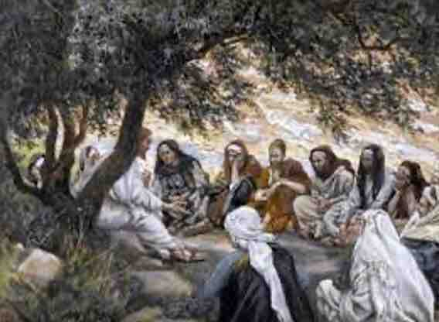
Jesus went on with his disciples to the villages of Caesarea Philippi; and on the way he asked his disciples, “Who do people say that I am?” And they answered him, “John the Baptist; and others, Elijah; and still others, one of the prophets.” He asked them, “But who do you say that I am?” Peter answered him, “You are the Messiah.” And he sternly ordered them not to tell anyone about him.
Then he began to teach them that the Son of Man must undergo great suffering, and be rejected by the elders, the chief priests, and the scribes, and be killed, and after three days rise again. He said all this quite openly. And Peter took him aside and began to rebuke him. But turning and looking at his disciples, he rebuked Peter and said, “Get behind me, Satan! For you are setting your mind not on divine things but on human things.”
He called the crowd with his disciples, and said to them, “If any want to become my followers, let them deny themselves and take up their cross and follow me. For those who want to save their life will lose it, and those who lose their life for my sake, and for the sake of the gospel, will save it. For what will it profit them to gain the whole world and forfeit their life? Indeed, what can they give in return for their life? Those who are ashamed of me and of my words in this adulterous and sinful generation, of them the Son of Man will also be ashamed when he comes in the glory of his Father with the holy angels.”
Anthem: Bless Oh Lord us thy servants (choristers prayer) by Martin Howe
Post Communion Prayer
Keep, O Lord, your Church, with your perpetual mercy; and, because without you our human frailty cannot but fall, keep us ever by your help from all things hurtful, and lead us to all things profitable to our salvation; through Jesus Christ our Lord. Amen.
News and Notices
- Haiti: We have been able to send £230 to Christian Aid Haiti appeal.
- St Anne’s Cream Teas: This year’s Take Away Teas during the summer has raised £525 to help the running costs of our beautiful St Anne’s Church. Sue Blore writes: “thank you to Judy who suggested and supplied the tea bags included in the boxes. Thanks to everyone who helped with boxes, and a special thank you to all those who bought teas again and again”. Congratulations and thanks to you too, Sue.
- Opera Classics Concert: This afternoon at 4:00pm, we will welcome international opera singers Peter and Verity Auty to St Nicolas, singing their favourite songs, arias, and duets. A few tickets at £20 still available this morning from Tony. Tickets are £25 on the door.
- Bag2thefuture: This is the final call to remind you that we can all bring in items for the bag collection next Sunday (19th) . Apart from clothing, they accept paired shoes (tied together), handbags, hats, scarves and ties, jewellery, lingerie, socks, belts, soft toys, household linen, curtains, towels, bedding (NOT duvets, blankets, pillows, cushions carpets, rugs, mats, school uniforms, corporate clothing or off-cuts. We get the money by the weight of the collection so - the more the merrier!
- Another date for your diary: Pam Taylor is organising a MacMillan Coffee Morning in church on Friday, 24th September from 10:00 until 12:00. Please do support this if you can.

- Endeavour – Episode 2 of the new series of Endeavour filmed in St Nicolas Church and around Taplow village will be shown at 8pm on Sunday 19th September on ITV. Look out for familiar locations!

